PENETRATION TESTING REPORT
EXPLOITATION & WEB APPLICATION PENTEST
W4-PM-FINAL | CYBERSECURITY | NETWORKWALKS
Pentester Name (Cybersecurity Professional) | Alfred Owino
Program / Batch | B083 - Networkwalks
Date | 1st October 2026
Milestones completed | M1 - Initial Access (retrieve 3 patient PDF reports)  M2 - Data Extraction (crack the 3 files)  M3 - Attack (staff salaries & shareholder details)  M4 - Penetration Testing Report
Client / Target | Mediroza General Hospital  https://medirozahospital.com  (black-box, authorised lab target)
Permission secured from client? | Yes. This engagement was performed under written authorisation from Networkwalks. Testing was limited to the target domain only; no denial-of-service and no social engineering were performed.
Phases covered | Reconnaissance, Content Discovery, Exploitation, Post-exploitation, Reporting
1. Liability Disclaimer
I have performed these activities only on the target I was authorised to test. The Mediroza target and all materials were provided by Networkwalks for this exercise, under written permission, and are for education only. Do not use anything from here to break the law. The instructor, the authors and Networkwalks are not responsible for what you do with this knowledge. Unauthorised access to systems you do not own is a crime in most countries even when nothing is damaged.
2. Introduction
This report covers the Week 4 capstone of my Networkwalks cybersecurity internship: a full black-box penetration test of Mediroza General Hospital's public web application. The engagement had four milestones - gain initial access and retrieve three confidential patient PDF reports (M1), crack the encryption on those files (M2), locate the hospital's staff salaries and shareholder details (M3), and produce this professional report (M4).
The assessment found the application to be critically insecure: a publicly exposed database backup and a SQL-injection authentication bypass each allow a complete compromise of confidential data. All four milestones were achieved. Sensitive answer values (the exact injection payload and the recovered file passwords) are redacted in the screenshots below so the report can be shared without giving away the lab solution.
3. Tools Used
The table below lists each tool used in this engagement and its purpose.
Tool | Purpose
whois | Query the public domain registration record (registrar, dates, DNSSEC).
nslookup | Resolve the domain to its IP address.
whatweb | Fingerprint web technologies (server, CMS).
curl -I | Read the HTTP response headers.
wafw00f | Detect whether a Web Application Firewall protects the site.
dnsrecon | Enumerate the DNS footprint (NS, MX, SPF, DMARC, DNSSEC).
Web browser + DevTools | Content discovery, form/source inspection, and manual exploitation.
John the Ripper | Offline password cracking of the encrypted PDF files.
Networkwalks Hash Calculator / Password Cracker | Extract the PDF hash and crack it in the browser.
4. Activities Performed
4.1 Reconnaissance (Footprinting)
Passive and light reconnaissance was performed to fingerprint the target before any attack.
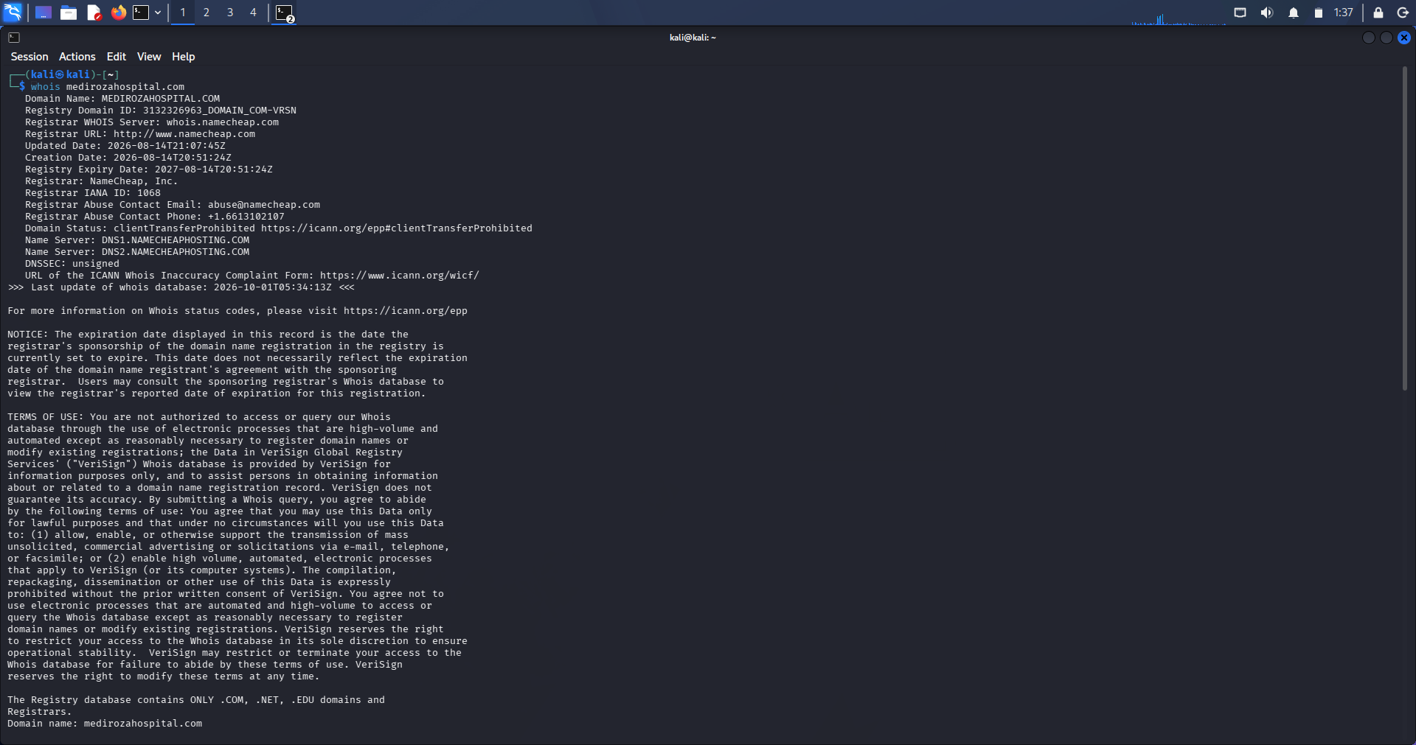
Figure 1 - whois
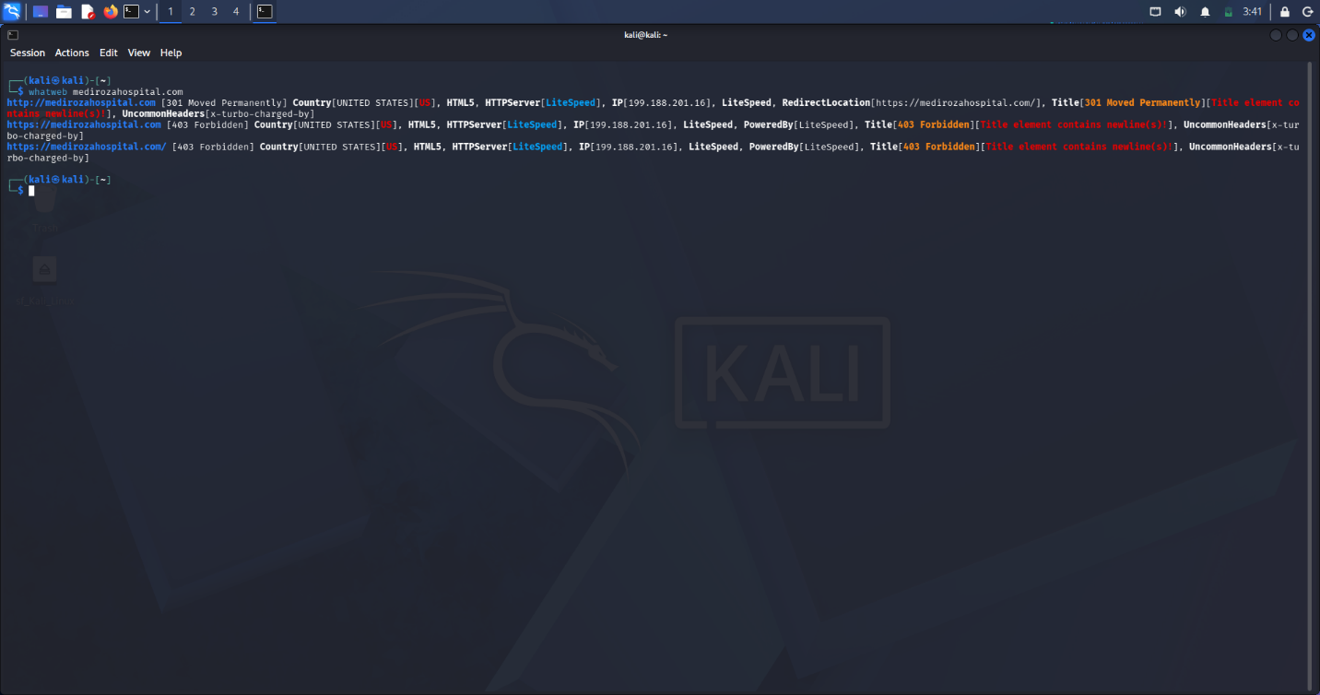
Figure 2 whatweb

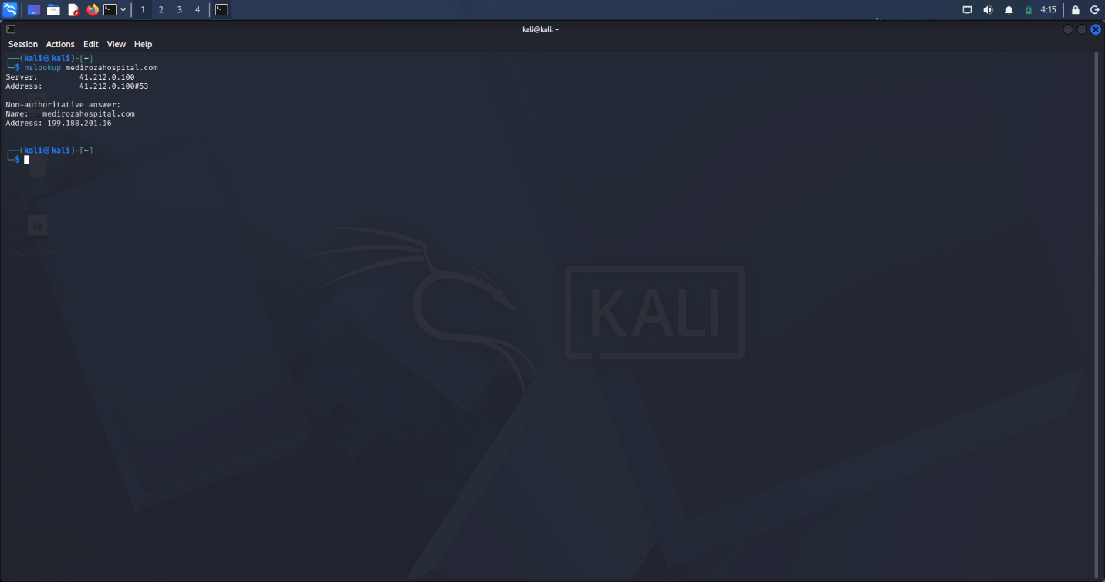
Figure3 nslookup
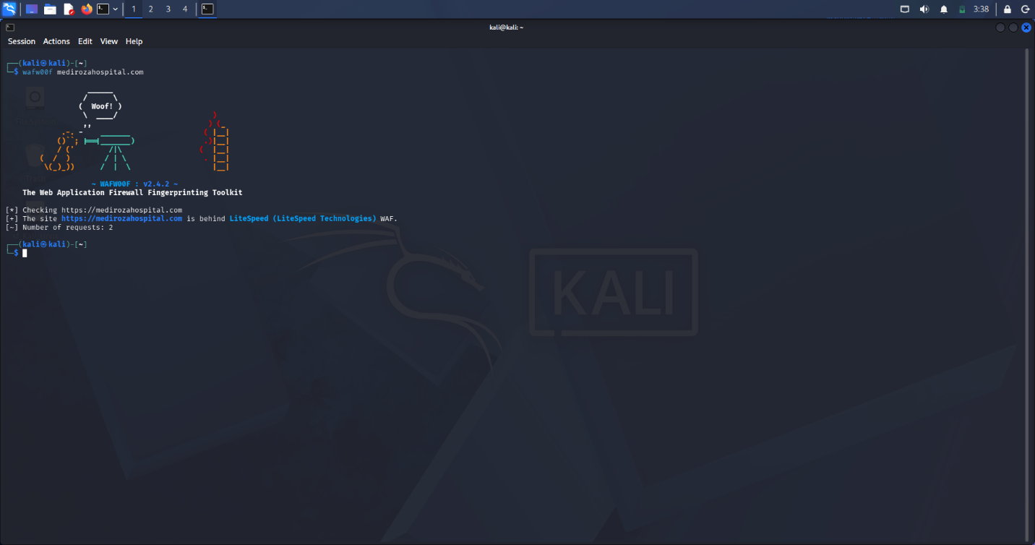
Figure 4 - wafw00f:

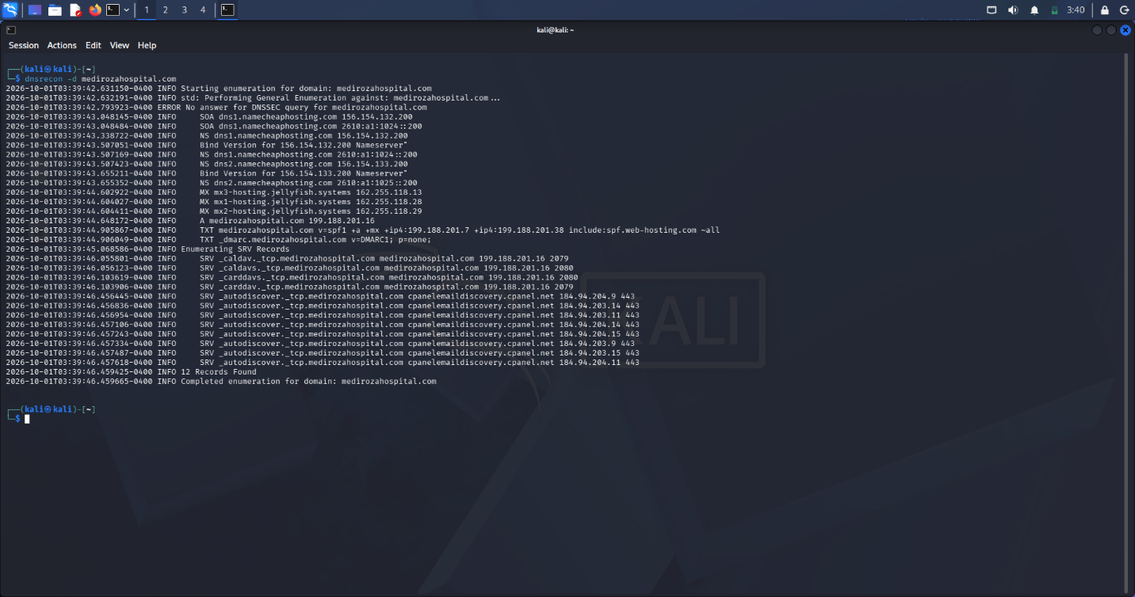
Figure 5 - dnsrecon:
Key facts: IP 199.188.201.16 (Namecheap shared hosting); LiteSpeed server with an OpenResty/CDN front; Mediroza CMS 1.4.2; no WAF; SPF ~all and DMARC p=none (e-mail spoofing exposure); DNSSEC unsigned.
4.2 Content Discovery & Critical Data Exposure (Milestone 3)
robots.txt discloses a hidden /old/ directory. Directory listing is enabled there, exposing a full SQL backup of the HR database, downloadable with no authentication.
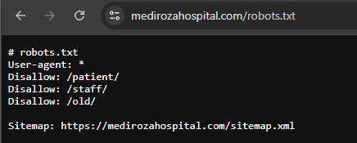
Figure 6
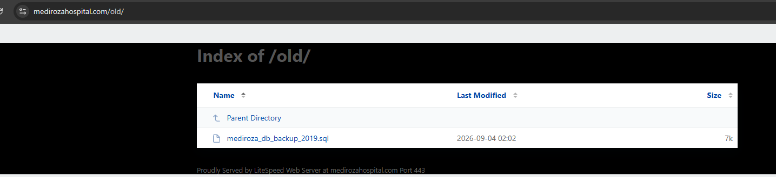
Figure 7
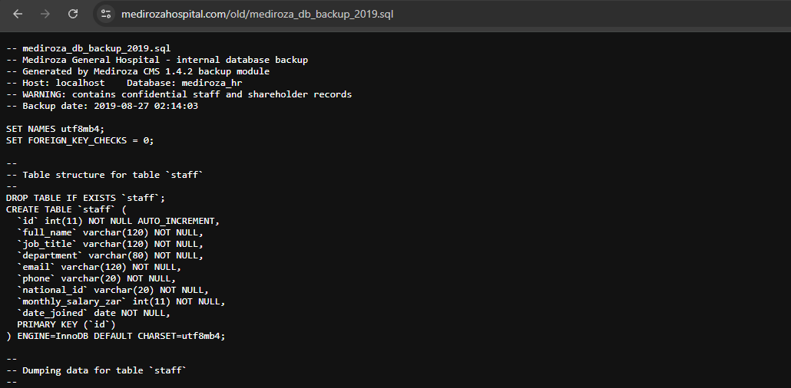
Figure 8
The backup exposes 30 staff records (name, title, department, e-mail, phone, national ID, monthly salary) and the full shareholder register - satisfying Milestone 3. Highest salaries and top shareholders are summarised in Section 5.
4.3 Milestone 1 - Web Attack: SQL Injection Authentication Bypass
The patient portal login builds its SQL query directly from user input. A SQL-injection payload entered in the username field comments out the password check, logging the attacker in without a valid password. The exact payload is redacted below.
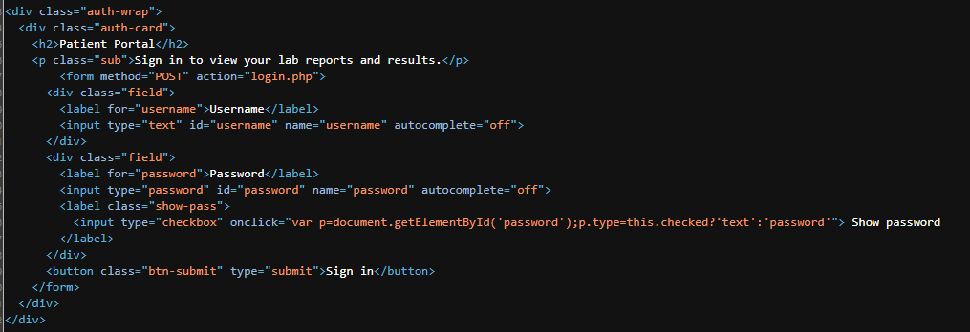
Figure 9

4.4 Milestone 2 - Cracking the Encrypted Files
The three retrieved PDFs were password-protected. A locked PDF stores a one-way hash of its password, so cracking is entirely offline - no contact with the server, no lockout, no logs. All three passwords were extremely weak and were recovered against a wordlist in seconds. The recovered passwords are redacted below.

f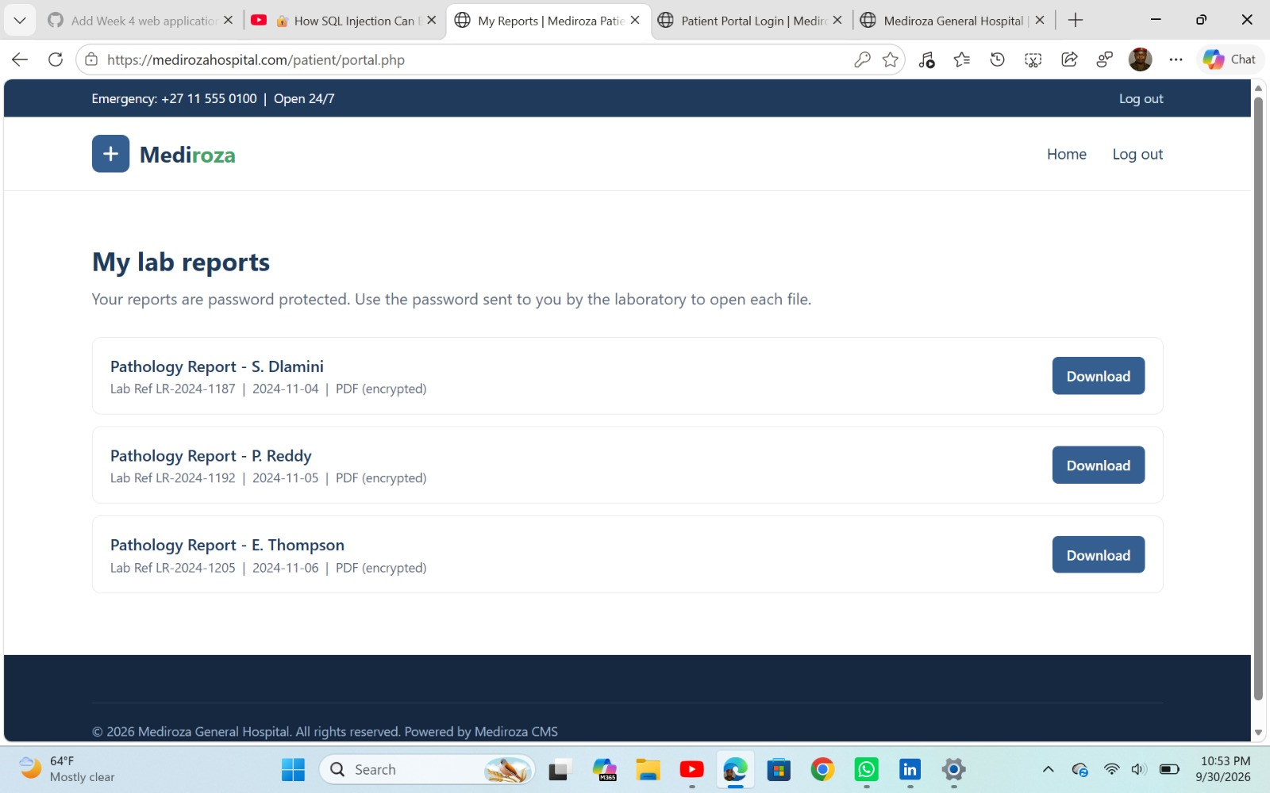
Figure 10

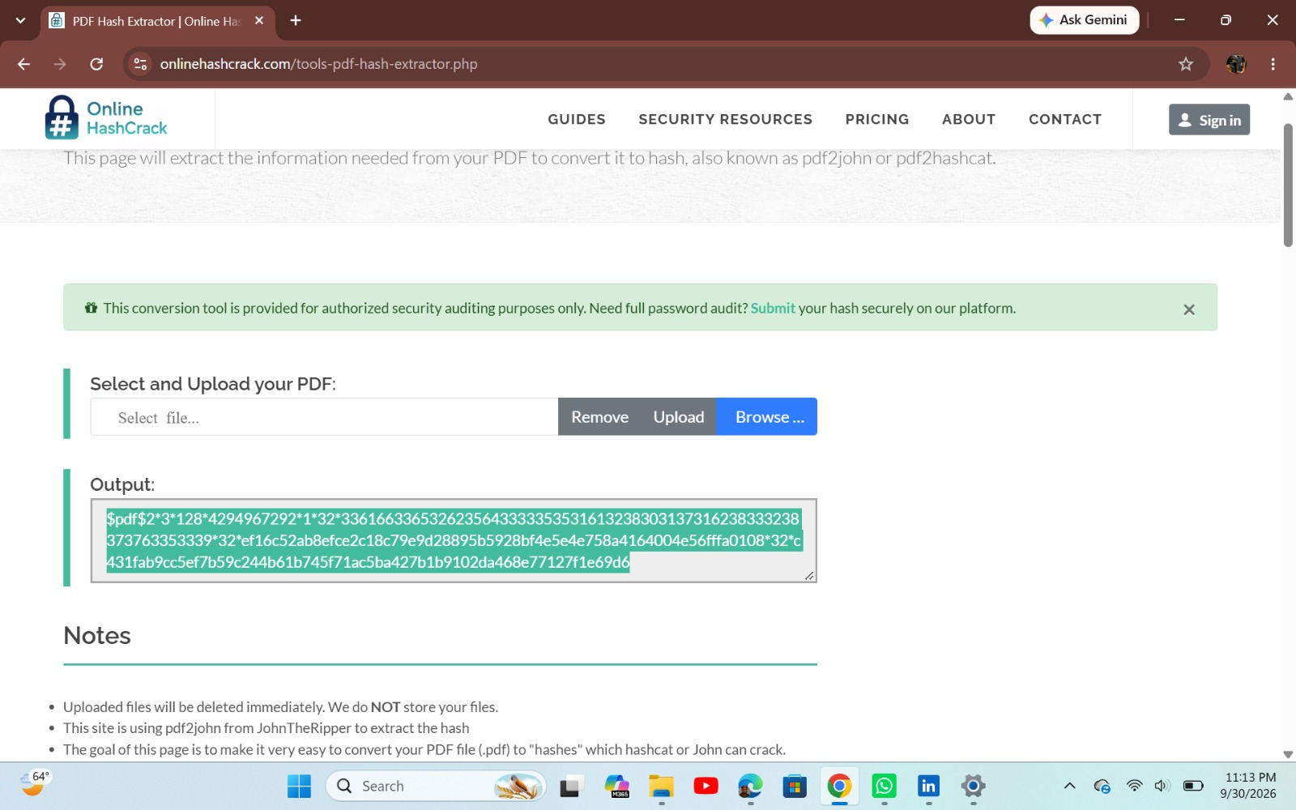
Figure 11

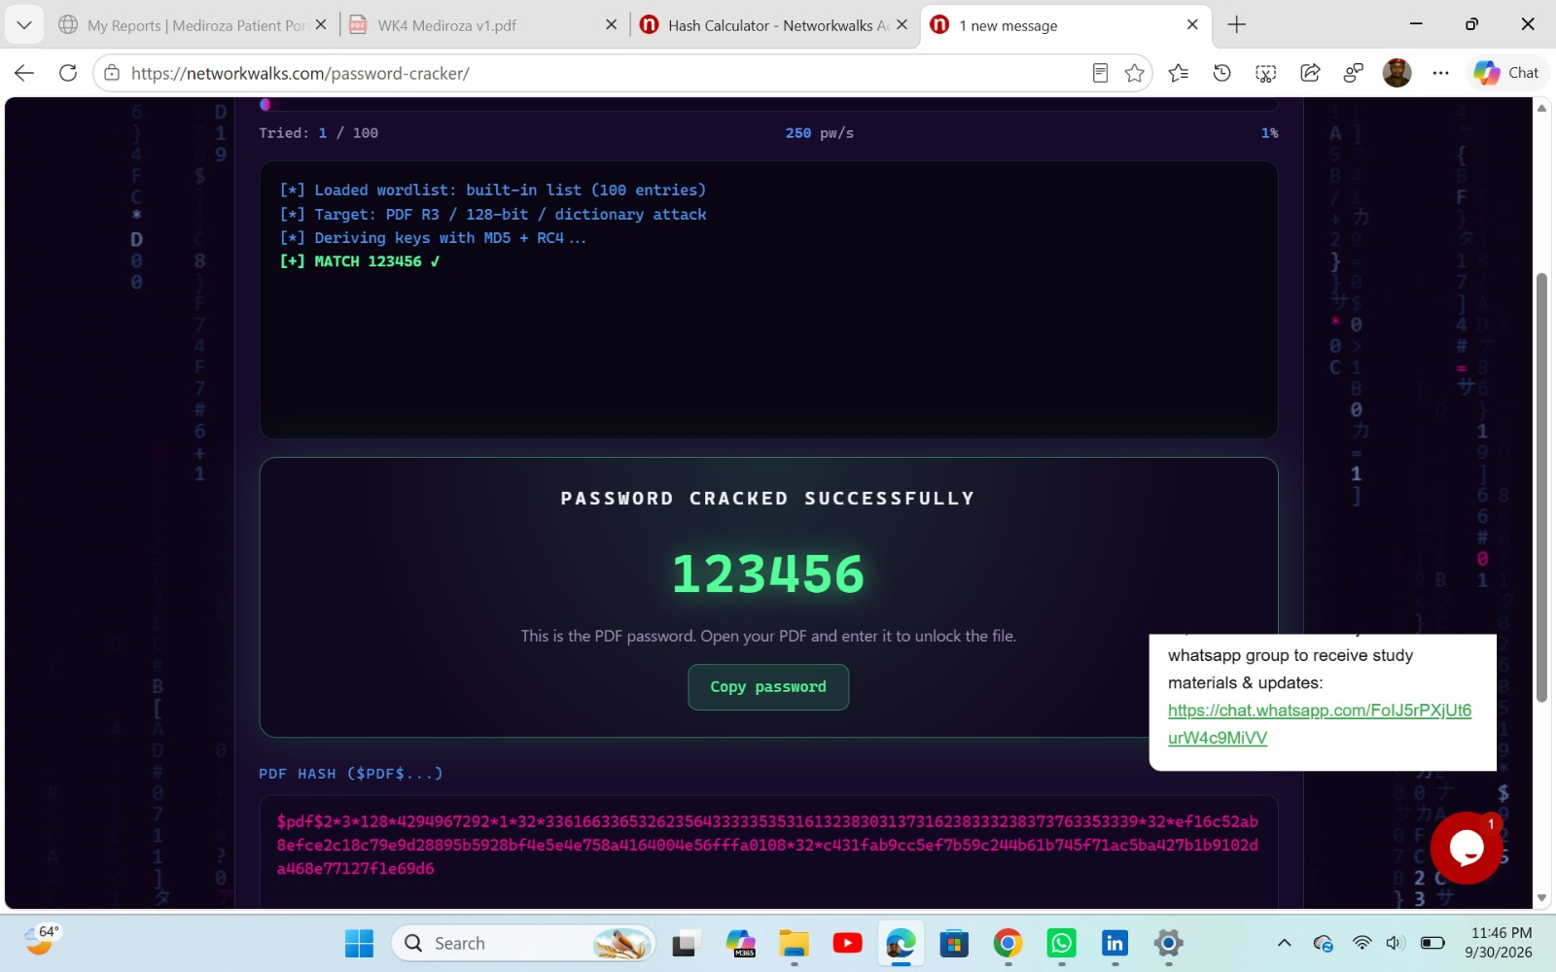
Figure 12
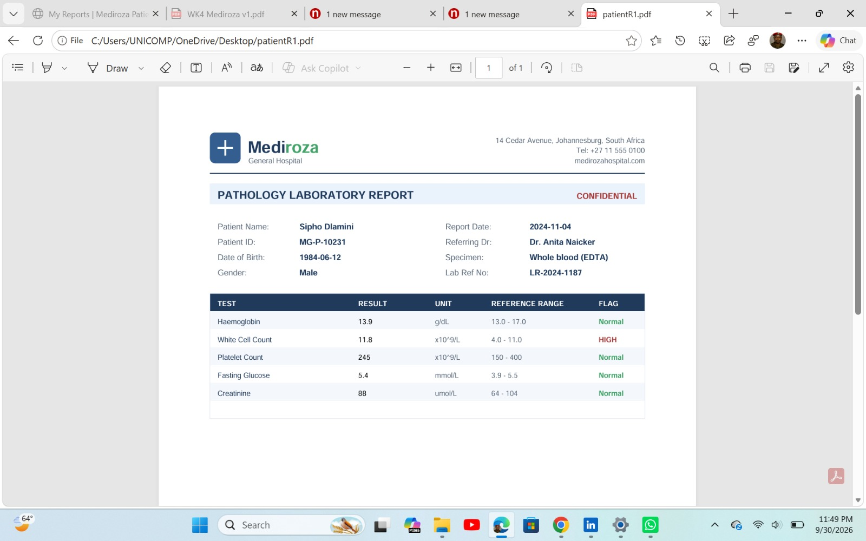Figure 13

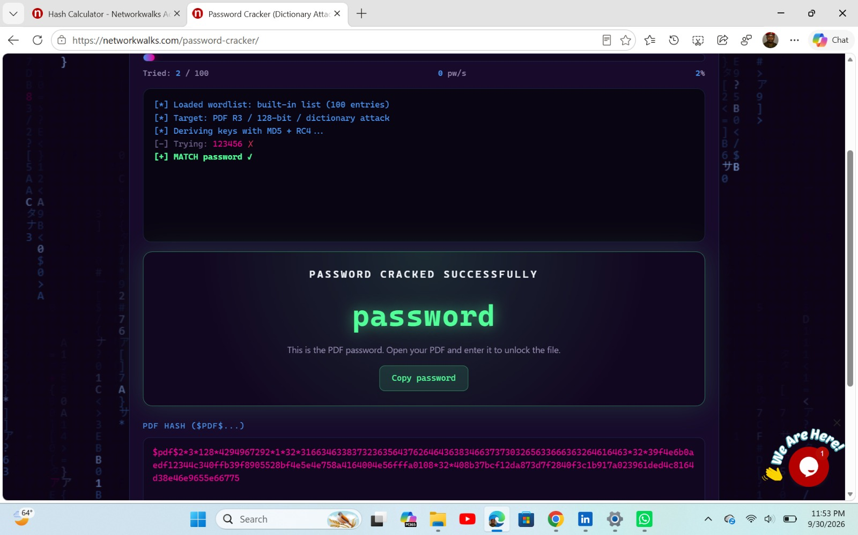
Figure 14

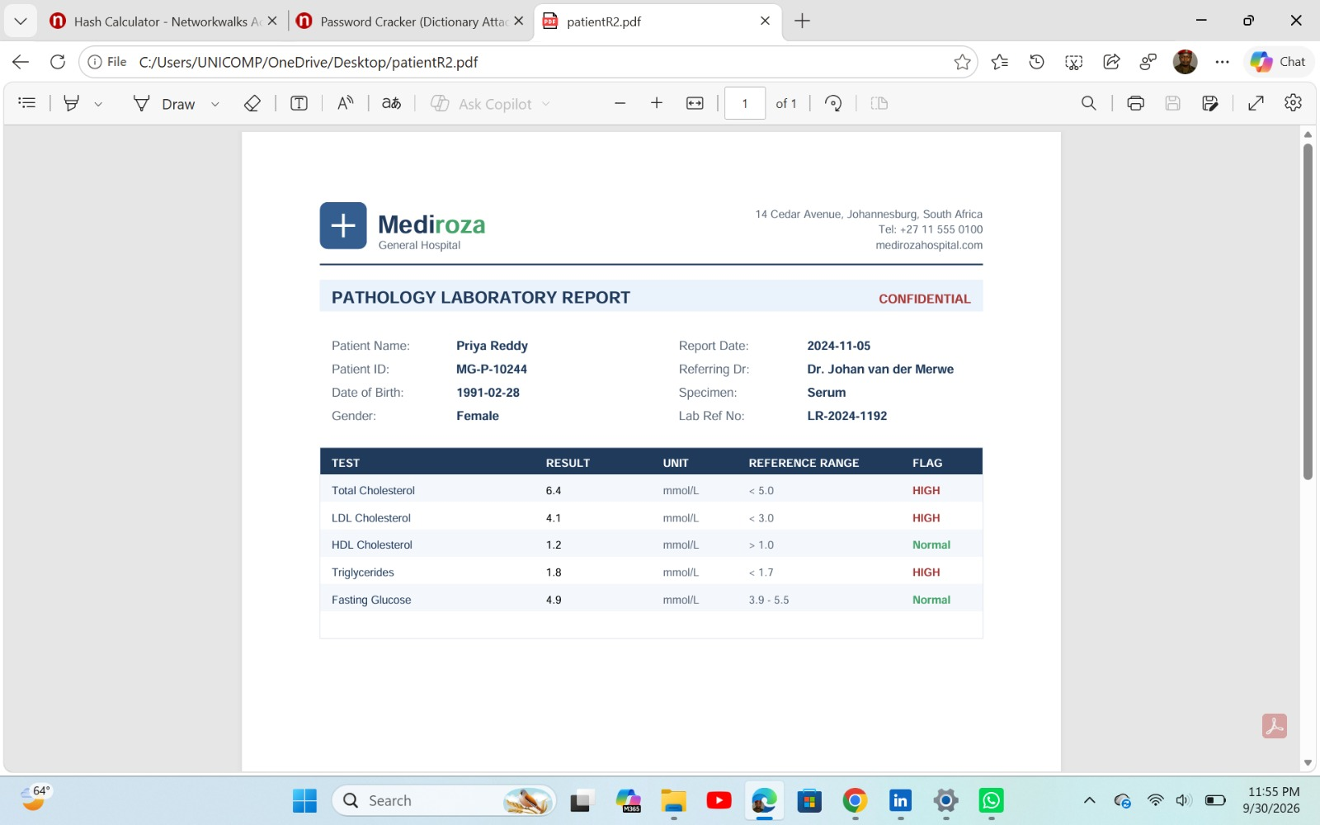
Figure 15

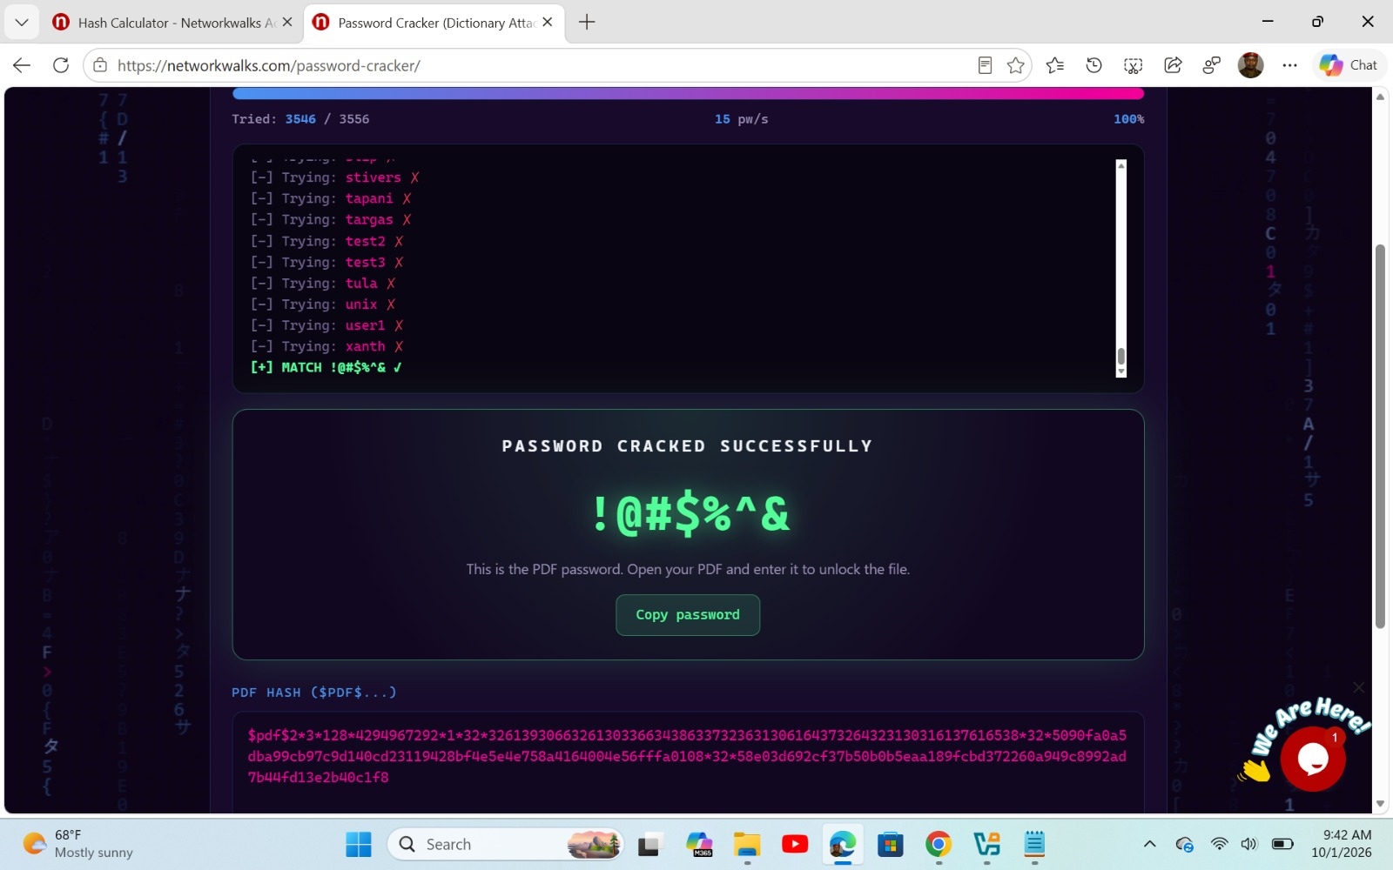
Figure 16

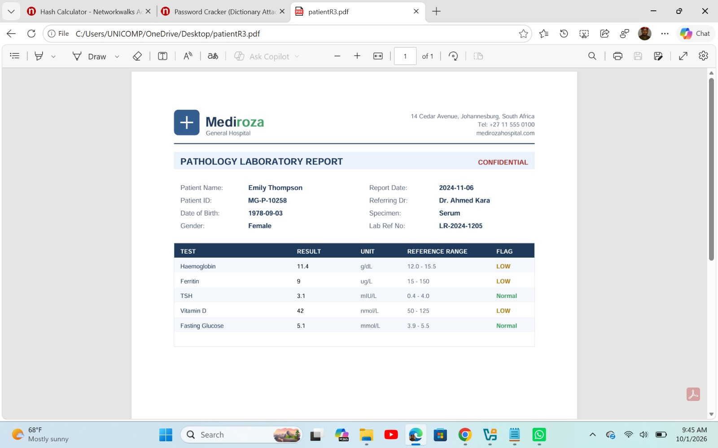
Figure 17

Lesson: the generic list missed the symbol password, but a targeted keyboard-pattern wordlist recovered it immediately - the right wordlist is what matters. All three passwords were weak patterns present in public lists - satisfying Milestone 2.
5. Recovered Confidential Data
5.1 Patient reports (M1 & M2)
File | Patient | Lab Ref | Password
report 1 | Sipho Dlamini (MG-P-10231) | LR-2024-1187 | 123456
report 2 | Priya Reddy (MG-P-10244) | LR-2024-1192 | password
report 3 | Emily Thompson (MG-P-10258) | LR-2024-1205 | !@#$%^&
(Passwords redacted. All three were weak and recovered in seconds.)
5.2 Staff salaries - highest paid (M3)
Name | Role | Salary (ZAR/mo)
Dr. Johan van der Merwe | Medical Director | 160,000
Sarah Botha | Chief Financial Officer | 152,000
Dr. Rajesh Naidoo | Chief Pathologist | 138,000
Dr. Vikram Chetty | Anaesthetist | 135,000
Dr. Anita Naicker | Consultant Cardiologist | 132,000
Dr. Suresh Moodley | Consultant Radiologist | 130,000
(30 staff records exposed in total, including national ID numbers.)
5.3 Shareholders (M3)
Shareholder | Share % | Class
Dr. Rajesh Naidoo | 18% | Ordinary
Cedar Health Holdings (Pty) Ltd | 15% | Ordinary
Dr. Johan van der Merwe | 12% | Ordinary
Reddy Family Trust | 11% | Ordinary
Thabo Molefe | 10% | Ordinary
Sarah Botha | 9% | Ordinary
Dr. Ahmed Kara | 8% | Preferential
Naledi Zulu | 7% | Ordinary
Michael Roberts | 6% | Ordinary
Dr. Vikram Chetty | 4% | Preferential
6. Risk Analysis
ID | Finding | Rating
F1 | Public database backup (staff PII, salaries, shareholders) | CRITICAL
F2 | SQL injection - authentication bypass | CRITICAL
F3 | Weak encryption passwords on patient files | HIGH
F4 | Directory listing enabled | MEDIUM
F5 | Username enumeration on patient login | MEDIUM
F6 | E-mail spoofing exposure (SPF ~all / DMARC p=none) | MEDIUM
F7 | Sensitive path disclosure via robots.txt | LOW
F8 | No WAF / no DNSSEC / exposed error log | LOW
7. Recommendations & Remediation
Immediate (Critical)
- Remove the /old/ directory and the database backup from the web root now; never store backups in a web-accessible path. Treat as a reportable POPIA breach and notify affected staff.
- Fix the SQL injection: use parameterised queries (prepared statements) everywhere; never concatenate user input into SQL. Rotate exposed credentials.
Short term (High / Medium)
- Enforce strong passphrases on patient files; the current passwords are trivially crackable.
- Disable directory listing (auto-index) on all folders.
- Return a single generic login error to stop username enumeration.
- Set SPF to -all and DMARC to p=reject to stop e-mail spoofing.
General hardening (Low)
- Do not list sensitive paths in robots.txt; protect them with authentication.
- Move the error log out of the web root; enable DNSSEC; consider a WAF.
- Store patient reports outside the web root and serve them only after a per-user ownership check.
8. Conclusion
Mediroza General Hospital's web application is critically exposed. Without any advanced technique, an anonymous attacker can download the entire HR database and bypass the patient login to read confidential medical reports. Two Critical findings, one High and several supporting issues combine into a complete compromise of patient, staff and shareholder confidentiality. Fixing the two Critical items (remove the exposed backup; parameterise the SQL queries) and enforcing strong passwords would remove the most severe risk immediately. All four engagement milestones were completed and evidenced in this report.

-End-

👤 Author
Alfred Owino
Cybersecurity Professional B083
LinkedIn www.linkedin.com/in/alfred-owino-a4a34021b

📌 Project Information
Program Name: Cybersecurity program at Networkwalks | Week: 04 | Repository: GitHub

